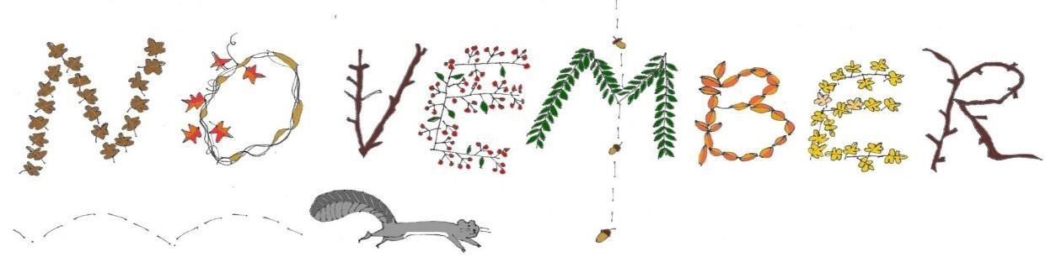
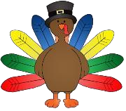
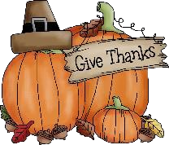

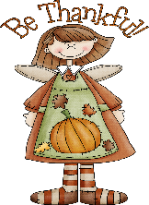
Here we are in November and we couldn’t be more “Thankful” for all our students and the support from our parents this school year. November is a short month for us filled with fun activities. You will soon notice a turkey bulletin board outside our classroom with individual feathers of what we are thankful for this year. Also, the children will be painting with turkey feet, making popcorn and creating owls throughout the month. We will start recognizing how nice it is to share materials and how it makes people feel with appropriate modeling and positive reinforcement. In the spirit of being thankful, the school we will be accepting donations of non-perishable items November 1st – 19th, to be donated to the West Springfield Parish Cupboard.
This Photo by Unknown Author is licensed under CC BY-SA-NC
We continue to go outside as the temperature drops so, please remember to dress your child properly every day with a warm jacket, sneakers, hats and mittens. Also, please remember to change out your child’s spare clothes for warmer fall/winter clothes.
This month our shape is a TRIANGLE and our color is BROWN. Our theme in the classroom will reflect homes, families and turkeys. Our Science Center will have a light table for the children to explore color mixing and building. Our Writing Table will have counting owls to sort by color and count to 10 with. Since we are preparing for Thanksgiving and continuing to talk about the New England Fall weather, our Sensory Table will be filled with turkey feathers, colorful fall leaves and a lot of hay. Our friendly skeleton will come down in our library and will be replaced with a tee pee for quiet reading time. Finally, our Dramatic Play Area will transform to a home like environment with a laundry line to hang up towels fresh out of the washing machine, a table to set for a thanksgiving feast and a refrigerator full of life like food boxes.
Please help us fill our kitchen with empty food boxes and clean plastic food containers by bringing them to school. The children will have fun serving some of their favorite foods to their friends!
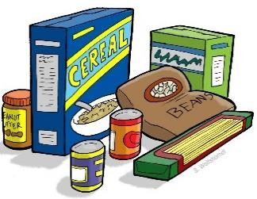
As always, thank you for sharing your children with us, we are thankful for each and every one of them.
Mrs. Hosmer and Mr. C

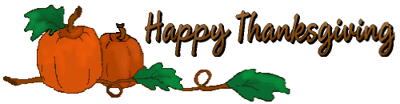
Upcoming Dates To Remember:

November 1-19th – Non-perishable Food Drive for Parish Cupboard
November 11th – No School – Veterans Day
November 24th – Early Dismissal at 12pm
November 25th – 26 – No School - Thanksgiving Holiday

-

