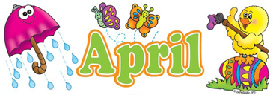
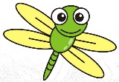

A big part of my teaching strategy is to involve the children in planning what will be happening in our classroom each month. This month, as a group, we have decided to learn more about insects and camping! Our Dramatic Play Area has been transformed into a campground complete with tents, cabins, outdoor cooking materials, a fish pond and woodland creatures. Our Block Center has some new visitors…giant insects! We will build insect habitats out of the blocks as we engage in this area. We have also added the dollhouse to this learning center and I wonder if the bugs will invade? Our Texture Table is a fun place to explore and “catch” insects in our viewing bottles. We have added tweezers to the table to further strengthen our fine motor skills. We will be creating shape bugs, using bug stencils at the painting easel, and making camping cabins out of craft sticks. We are looking for bugs while outdoors and hopefully we will catch a few to observe in our bug house. We plan to bring out the soccer net and basketball hoop now that the weather is getting warmer! In our classroom, we are continuing to work on our writing skills by introducing a new letter each week and many opportunities to print our first and last names.
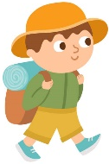
This month we have introduced a few new elements to our circle time routine. We will be using a “How Do You Feel” chart as we work on letting others know our emotions. In addition, the LEADER BAG will start going home with a child each day. With your help your child can select a special item to bring to school to show and tell their peers about during circle time! Please no weapons or items that promote aggressive play.
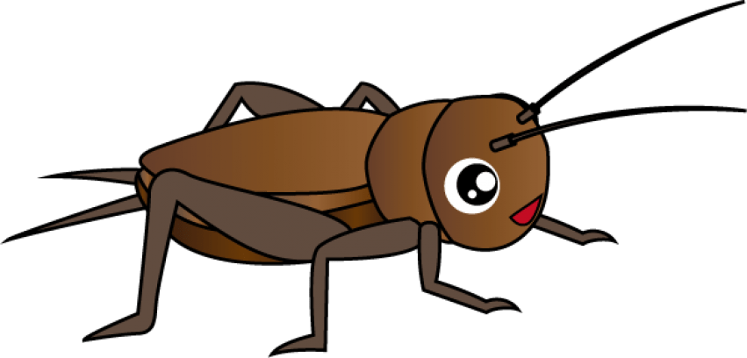
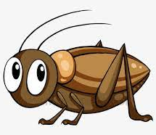
With the nicer weather we will be spending additional time outdoors. Please be sure your child has appropriate shoes and clothing so they will be comfortable while outside.
Thank you for sharing your children with me! They bring much joy and laughter into our classroom each and every day!
Mrs. Roit
Upcoming Dates To Remember:
-April 15 -- No School, Good Friday
-April 18-22 -- No School, Spring Break

