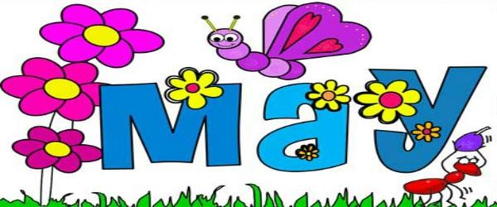

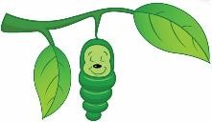
WOW! Where did the school year go? As we wrap up our school year and sit back and reflect, we are so proud of all the growth and accomplishments seen this year. We thank all of our wonderful families for all the gifts, donations and support throughout the year. We also thank you for sharing your children with us. We had a wonderful year watching them all grow so much in so many different ways.
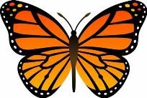
In May, we are watching and waiting for our caterpillars to turn into Painted Lady butterflies. We have introduced new words like “cocoon” and “chrysalis” to our students. Our Dramatic Play Area has changed to a fun and engaging kitchen area. The children have the opportunity to create delicious healthy meals for their classmates and teachers. We have put out new table toys for the children to explore. The Writing Center has dry erase boards for the children to strengthen their fine motor skills and to show us how creative they can be. We have decided for the last month of school water will be back in the Sensory Table. It has been a favorite for the children and a few have asked to have it back before school gets out! For the last month of school, we will be doing a lot of free art activities to further strengthen our fine motor skills.
The last week of May, we will be giving out May progress reports for you to sign. You will be able to take a copy home after they are signed. With the weather warming up so quickly, please remember that we play outside a lot and your children need to wear sneakers to school. Wood chips in between the toes does not feel good.
Sometimes it can get frustrating to stop playing with friends just to clean out our shoes. Also, if you feel like your child needs sunblock or bug spray, please apply it before school.
We all agree that we love our moms and grandmas so much that we decided to plants some flowers and try our hands at frosting and decorating cookies. They will be coming home with love on May 5th and 6th along with a few extra surprises.
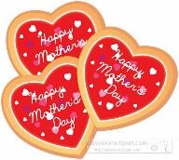

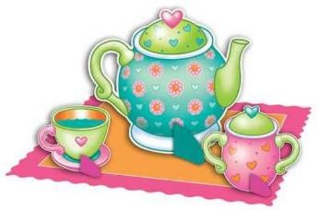
Thanks again for sharing your children with us. What a wonderful year we had!!
Mrs. Hosmer

