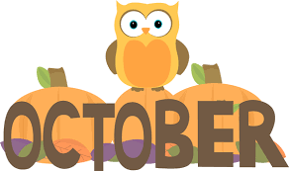

It is hard to believe that we have already been in preschool for a month! We have been focused on learning our classroom routines and rules and getting to know all of our new friends! We have spent lots of time outside and will continue to enjoy the beautiful fall weather. We do leave classroom windows open during the day so please be sure to send in a sweater or sweatshirt for your child to wear in the classroom if they get chilly.
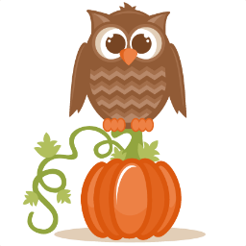
During the month of October some of the themes we will be exploring will include the Season of Fall, Squirrels & Owls, Apples & Pumpkins and Fire Safety. Our Dramatic Play area is now a farm stand that sells apples, pumpkins, apple pies, pumpkin muffins and fall flowers. The children will try on the roles of customer, baker, cashier and farmer as we continue to learn about sharing and taking turns! Our classroom will smell like fall as we cook and sample crockpot applesauce and manipulate cinnamon playdough. We will have an apple tasting and graph which type of apple we liked the best.
Our block area will become a farm, complete with barns, tractors and farm animals. We will talk about how farmers grow apples and pumpkins and how they care for their animals. In the science area, the children will be able to explore apples, pumpkins, gourds, leaves and Indian corn. We will also be on the lookout for the squirrels who like to frequent the playground. We have a great view of the playground from our classroom windows.
Our library area will hold all kinds of books relating to our October themes and fall flannel board pieces and puppets. In math center we will be counting pumpkins, sorting according to color and talking about more & less and small, medium and large.
During circle time we will be talking about fire safety and practicing Stop, Drop and Roll! We will get to meet firefighters and see their firetruck when they come for a visit in October.
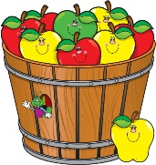
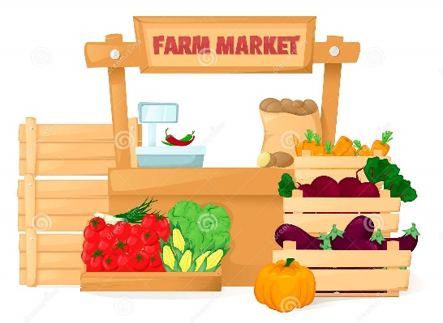
Friday, October 29th, will be Black & Orange Day and we will have all of our activities centered around these colors. At a later date in October, we will post a sign-up sheet outside our classroom door so parents may volunteer to bring in goodies and supplies for our special activities.
Thank You!
Mrs. Roit & Mrs. Protono

Upcoming Dates To Remember:
-Oct 5-29 -- Fall Fundraiser
-Oct 11 -- No School, Columbus Day
-Oct 20 -- School Picture Day, more info to follow
-Oct 28 -- Back to School Night, 5:30-7:00pm

